

Theme: eGreenNursery

Category: Website Design and

Development

TEAM NAME:

**THE WEB WIZARDS**

**GROUP MEMBERS:**

MADIHA ABDULRAHIM HAMNA ASHRAF

HAMMAD POPAT

IQRA

**CONTENTS**

**PROJECT TITLE INTRODUCTION OBJECTIVES PROJECT DURATION DESCRIPTION SNAPSHOTS**



Date: 08/12/2023

LEAFY HEAVEN

INTRODUCTION:

Hey there! Welcome to Leafy Heaven, the greenest corner. We have designed a website to be a hub of inspiration, knowledge and creativity, you can explore a variety of plants here. Get ready to dig in, and watch your gardening dreams bloom at Leafy Heaven!

“LET YOUR GREEN THUMB SHINE AT LEAFY HEAVEN !🍀”

OBJECTIVES:

DESIGN:

Starting from designing our website with great effort and affection heading towards to the product category and user friendly features, we have build our website with a distinctive and

engaging look that function flawlessly on all devices.

Responsive Website:

We have built a responsive website that includes all essential website features and elements.

Project Duration:

ANALYSIS: 5 HOURS DESIGN: 7 HOURS DEVELOPMENT: 16 HOURS TESTING: 3 HOURS DOCUMENTATION: 2 HOURS

DESCRIPTION :

Our website encompasses various sections and pages, including a user-friendly navigation bar, an inviting index page, a captivating gallery which on hover you can jump on portfolio page, our portfolio page is showcasing the beauty of nature, an informative FAQ section, a convenient feedback form to gather valuable insights, a convenient shop to purchase quality of plants, a dedicated contact page to get in touch with our team, a helpful site map for easy navigation.

With Leafy Heaven, we aim to provide a seamless user experience while inspiring and empowering individuals to create their own green paradise. Explore our website and discover the joy of gardening.

SNAPSHOTS :

**NAVBAR:**



**HEADER :**

Consist of slider

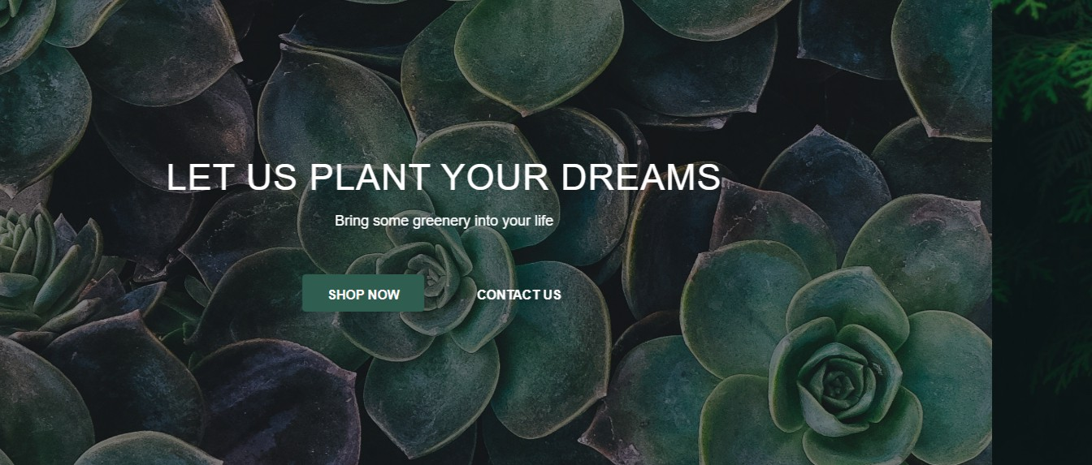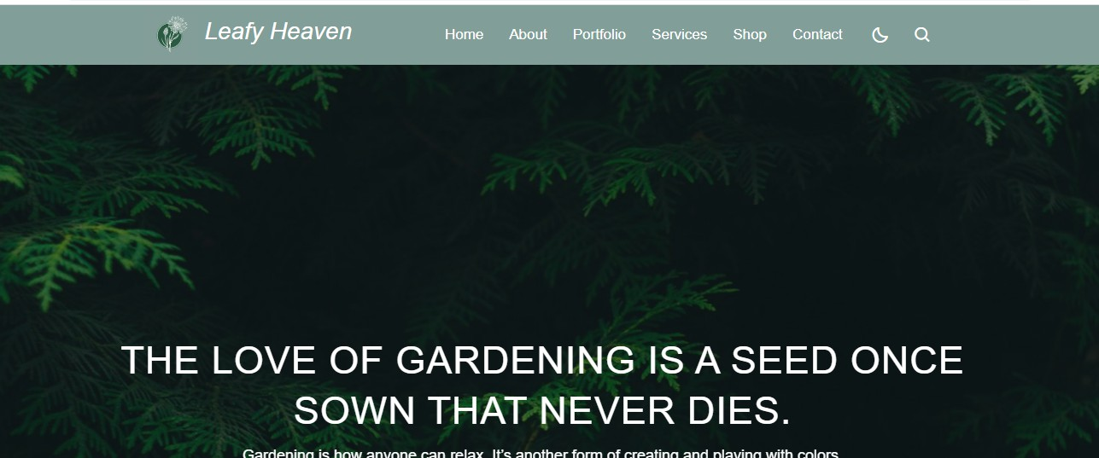

**SERVICES:**

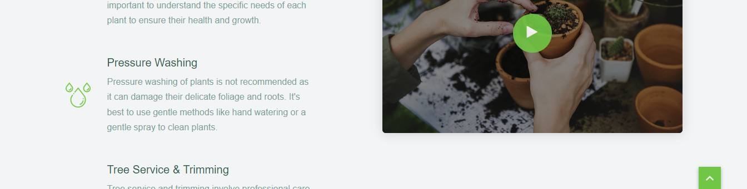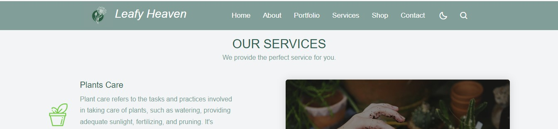

**ABOUT US:**

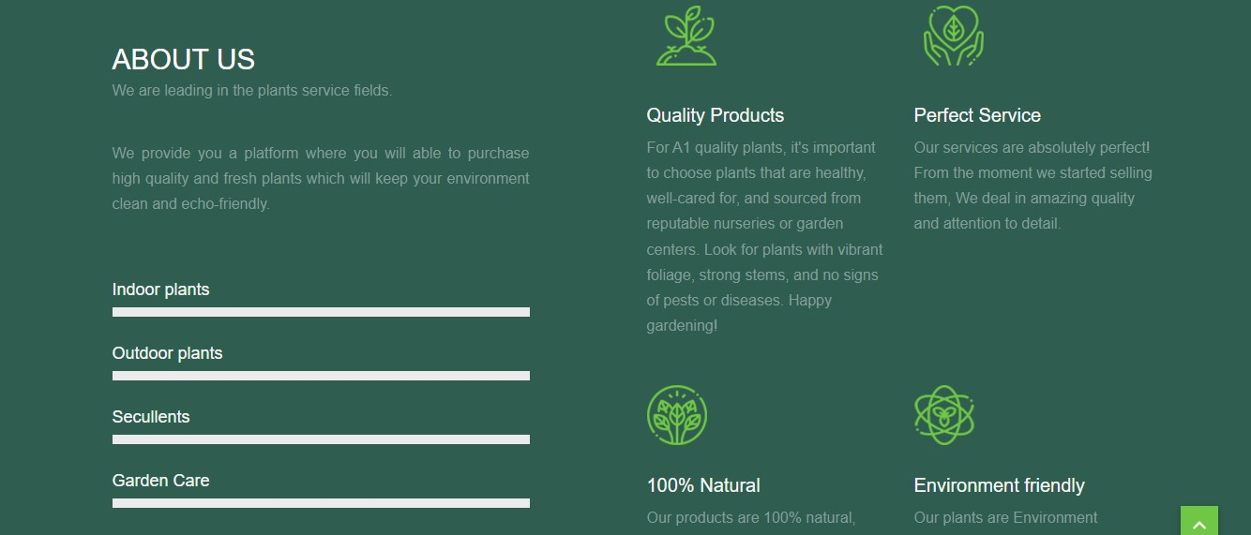

**GALLERY :**

Gallery on hover on last picture click on see more can jump to portfolio page

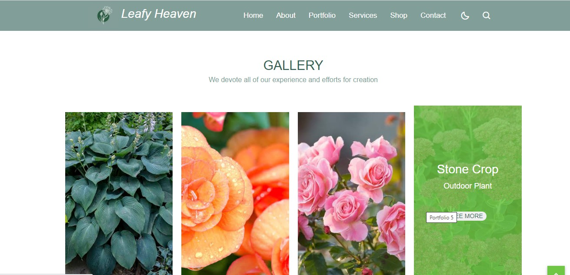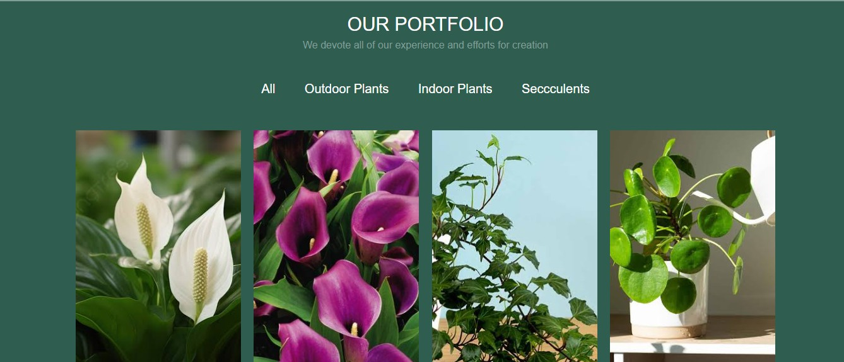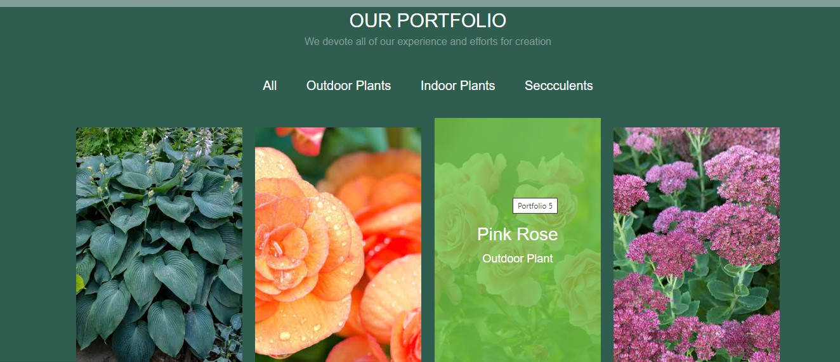

**FAQS:**

**FEEDBACK:**

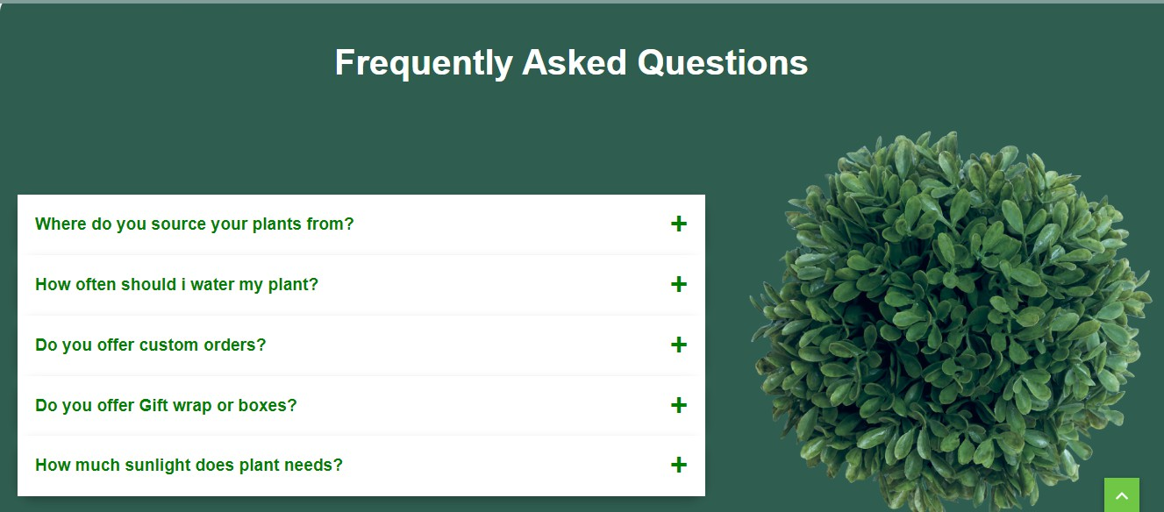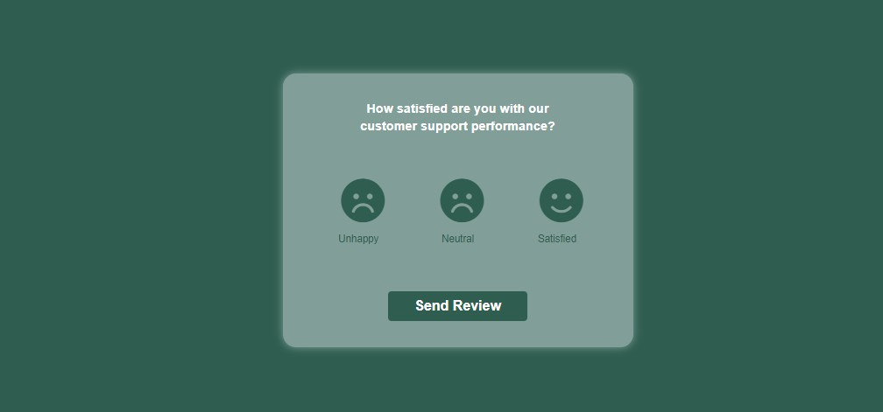

**CART:**

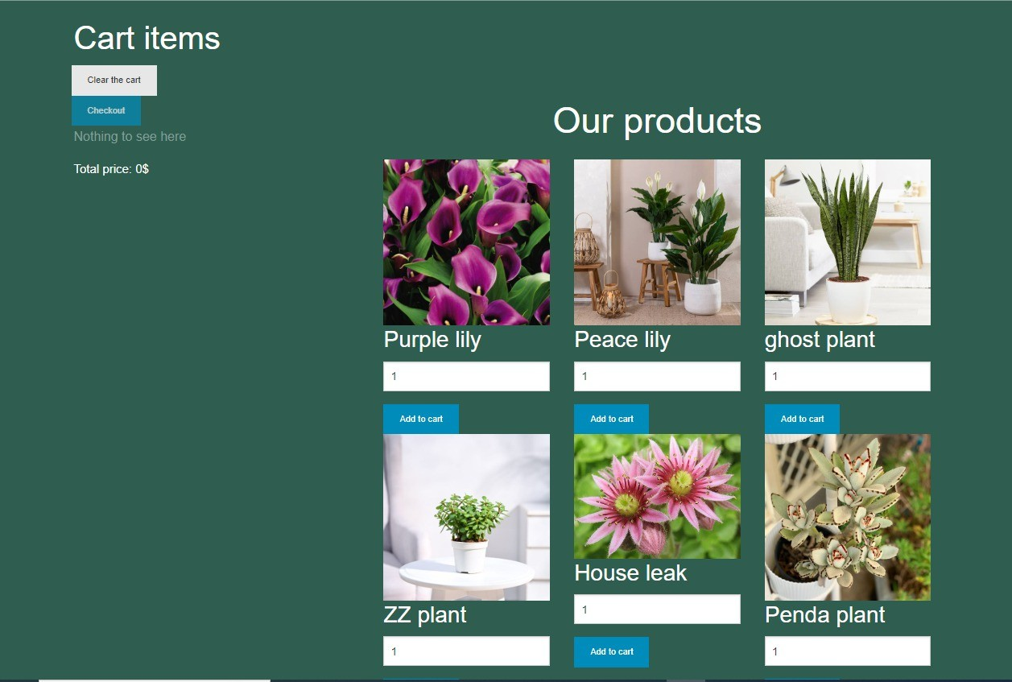

**TERMS & CONDITIONS**

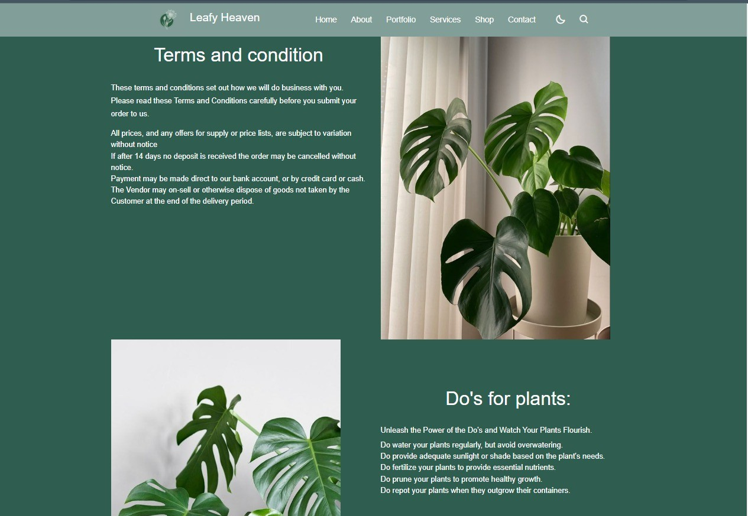

Thank you for taking the time to review our documentation.